**PODDAR BRIO** INTERNATIONAL SCHOOL(CBSE)

STUDENT NAME- Arabinda Chand

CLASS- 11

SUBJECT- Biology SUBJECT INCHARGE- Diksha Singh Ma’am

TOPIC- Study Of Effect Of Antibiotics On Microbes

Session-2020-2021

**C:\Program Files\Microsoft Office\MEDIA\CAGCAT10\j0305257.wmf**

**PODDAR BRIO**

SENIOR SECONDARY INTERNATIONAL SCHOOL (CBSE)

Poddar Evergreens Complex, Near Juveli Bridge, MIDC, Kalyan-Karjat Road, Village- Sape, Badlapur (E), Pin- 421503,

BIOLOGY JOURNAL

CERTIFICATE

Class : ……. Roll No. : …….. Examination Seat No. : ………..

THIS IS TO CERTIFY that the work entered in this journal is the work of Shri/Kumari ……………………..

who has worked for the year ……… in the Jr./Sr. College laboratory.

Teacher Incharge Principal

Date :

External Examiner College Stamp

***ACKNOWLEDGEMENT***

I would like to express my special thanks of gratitude to my teacher Ms. Diksha Singh as well as our C.E.O.- Mrs. Rashmi Singh , LAB Asst. Tushar Chaudhary& VICE PRINCIPAL Mrs. Sreerekha GopalKrishnanwho gave me the golden opportunity to do this wonderful project on the topic **Study Of Effect Of Antibiotics On Microbes**, also helped me in doing a lot of Research and i came to know about so many new things I am really thankful to them.  
Secondly i would also like to thank my parents and friends who helped me a lot in finalizing this project within the limited time frame.

***Index***

**Contents**

**Subtopic page no.**

|  |  |
| --- | --- |
| **Introduction** | **5** |
| **Aim** | **6** |
| **Requirement** | **7** |
| **Procedure** | **8** |
| **Part a** | **9** |
| **Part b** | **10** |
| **Observation** | **11** |
| **Conclusion** | **12** |
| **Reference** | **13** |

***INTRO***

**Antibiotics are the organic secretion produced by micro – organisms, which in low concentrations are antagonistic to the growth of other micro – organisms (mostly pathogens). Antibiotics have proved very useful in combating several bacterial diseases in man an animal. Antibiotics are commonly obtained from *actinomycetes* and some eubacteria. Some of the important antibiotics are *streptomycin, Aureomycin, teramycin, Chloromycetin, erythromycin, neomycin* etc.**

**Soil is a natural medium that harbors several types of micro – organism .These micro- organisms can be frown on culture media. The effect of different types of antibiotics can be studied on the growth of micro - organism growing in culture medium. This is an important subject, therefore the study of effect of antibiotics on micro - organism has been taken for the present project.**

***AIM***

The aim of this project is to study the effect of antibiotics on micro – organisms.

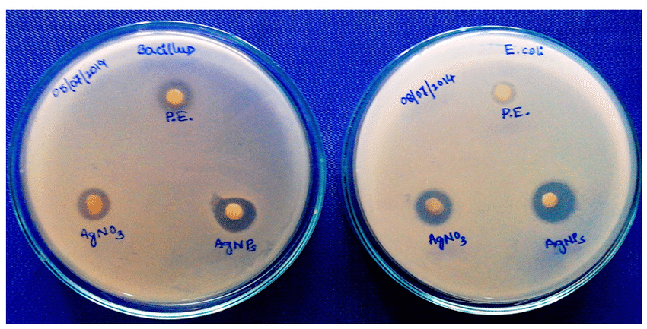

­­­­***REQUIREMENT***

1. POtato
2. agar
3. dextrose
4. distilled water
5. four different types of antibiotics (such as penicillin , streptomycin , aureomycin , teramycin )
6. syringe
7. oven sterilized petridish
8. flasks
9. beakers
10. pipettes
11. garden soil,
12. glass marker pen

***PROCEDURE***

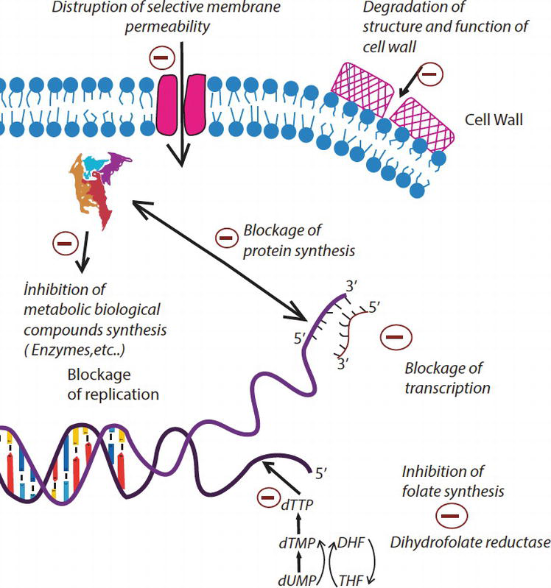

***A. Preparation of culture Medium***

1. Potato Dextrose Agar (PDA) Medium.

2. Take 200 g of peeled potato chips. Boil them with 500 ml of water in a beaker for 15 minutes.

3. Squeeze the potato pulp thus obtained through a muslin cloth and keep it in a flask.

4. Take 20 g of agar in a beaker and warm it with 500 ml of water .

5. Mix both the solution of potato and agar and add 20 g dextrose to it.

6. Thus one litre of PDA medium is prepared.

7. Autoclave the medium at 15 pounds pressure for 15 minutes.

#### *B. Effects of antibiotics on soil microorganisms*

i) Take 2 g of soil and dissolve it in 10 ml of water in a beaker. Let the soil particle settle down.

ii) Take 5 oven sterilized petridishes and pour 1 ml of soil suspension in each of the plates. Now pour 1ml of the four antibiotics separately in four petridishes with the help of syringe, and mark them with marker pen. Leave the fifth petridish without antibiotic to serve as control.

iii) Pour PDA in each of the petridishes and mix the suspension by rotating the petridishes. Leave the petridishes undisturbed at a warm place

### *Observation*

The effect of different antibiotics on the micro – organisms can be assessed by counting the number and size of the colonies growing in the petridishes.

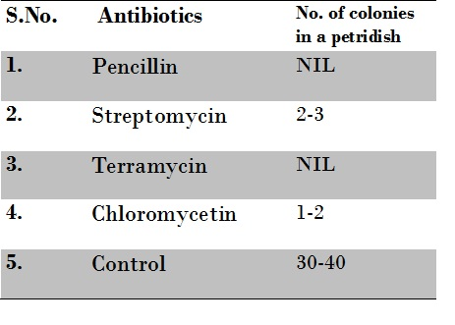

### *CONCLUSIONS*

Pencillin and Terramycin was most effective antibiotic against microorganism in soil

### *Reference*

1. Wikipedia

2. Science daily

3. Weekly

4. bioinfo.com

5. zizu.com

6. science for today

IMAGES

